**BACKEND API CALLS - DOCUMENTATION**

1. **UPLOAD PDF FILE**

**METHOD :**



**ROUTE :**



**REQUEST BODY :**

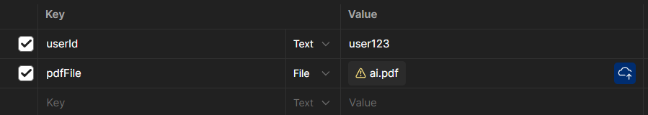

**RESPONSE BODY : (SUCCESSFUL UPLOAD)**

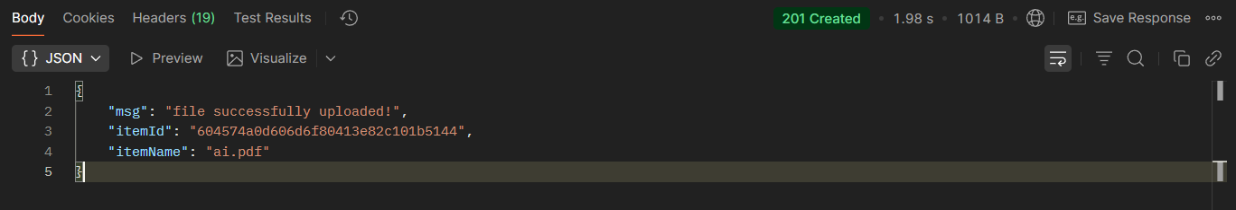

1. **GENERATE NOTES**

**METHOD :**



**ROUTE :**



**QUERY PARAMS :**

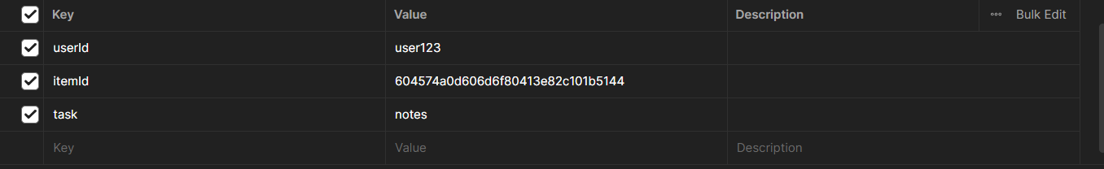

**RESPONSE BODY : (SUCCESSFUL)**

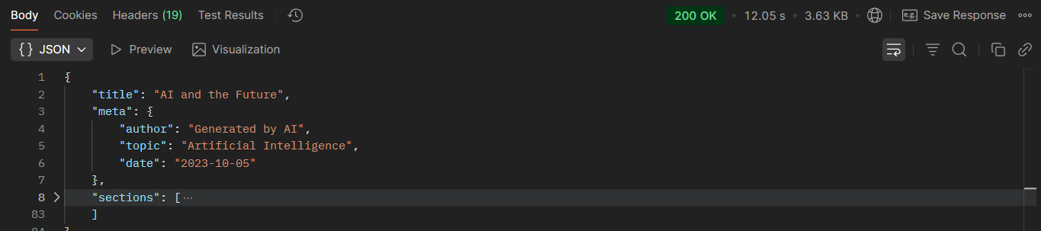

**sections is an array of objects of type:**

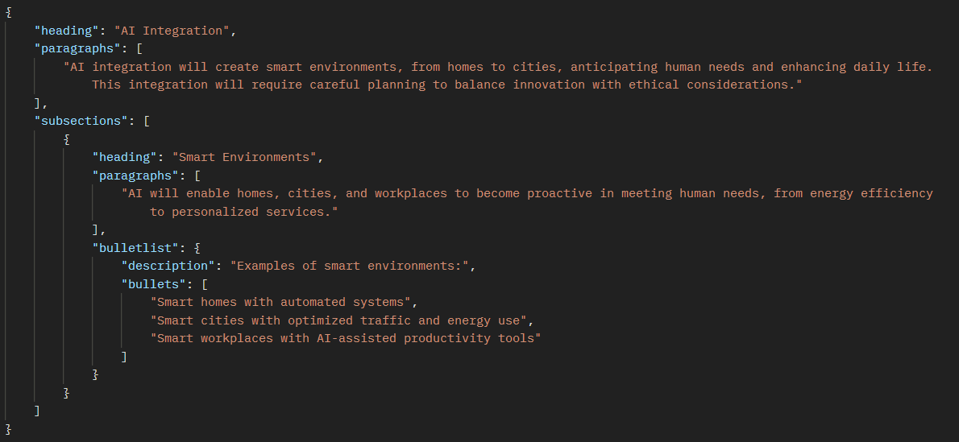

1. **GENERATE MCQS**

**METHOD :**



**ROUTE :**



**QUERY PARAMS :**

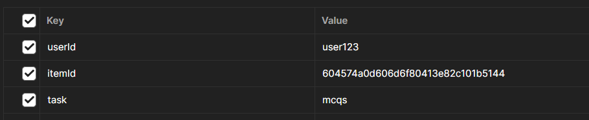

**RESPONSE BODY : (SUCCESSFUL)**

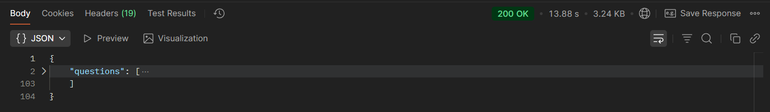

**questions is an array of objects of type:**

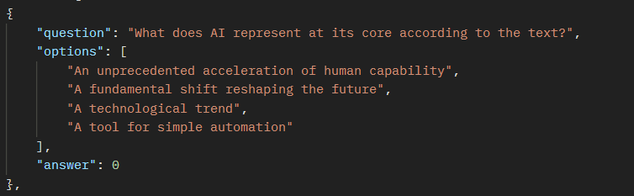

1. **GENERATE FLASHCARDS**

**METHOD :**



**ROUTE :**



**QUERY PARAMS :**

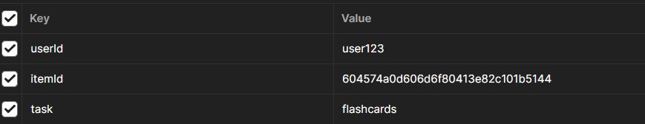

**RESPONSE BODY : (SUCCESSFUL)**

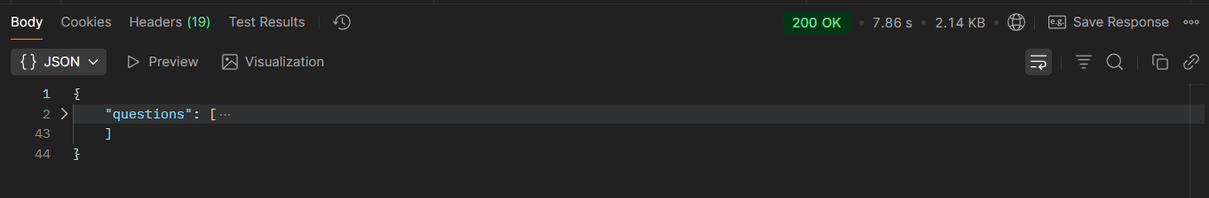

**questions is an array of objects of type:**

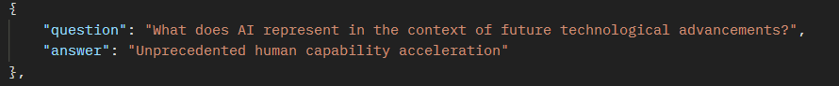

1. **EXPORT NOTES**

**METHOD :**



**ROUTE :**



**QUERY PARAMS :**



**RESPONSE: (SUCCESSFUL)**

**a pdf is generated**

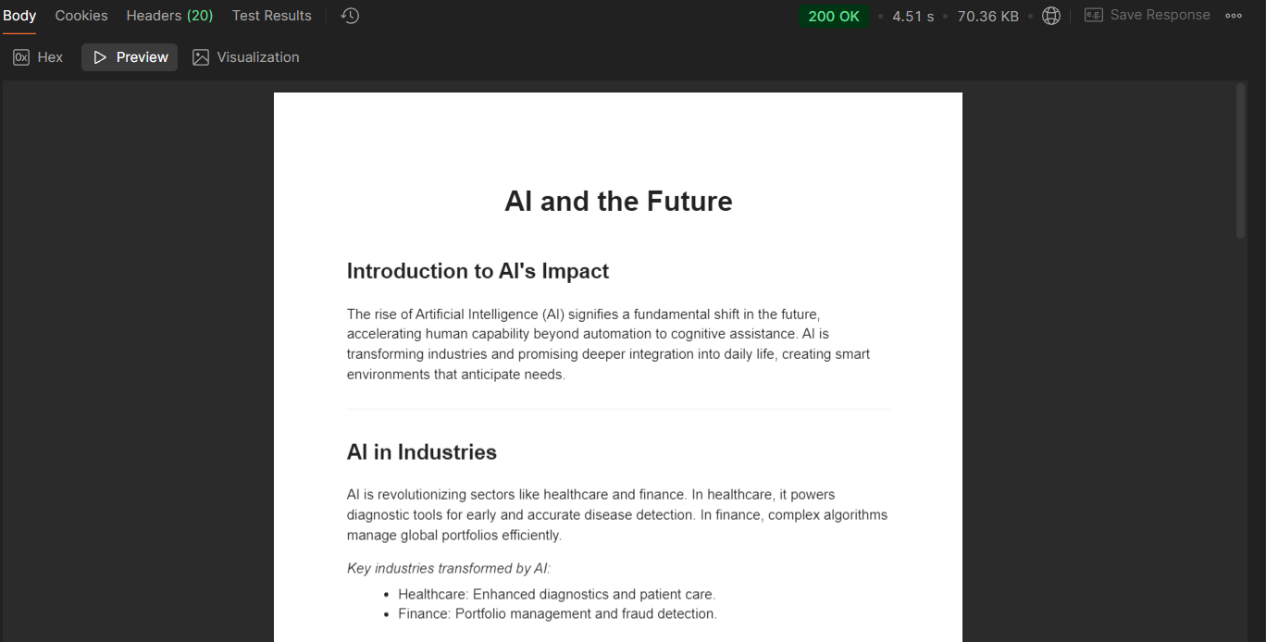

1. **SAVE NOTES**

**METHOD :**



**ROUTE :**



**REQUEST BODY :**

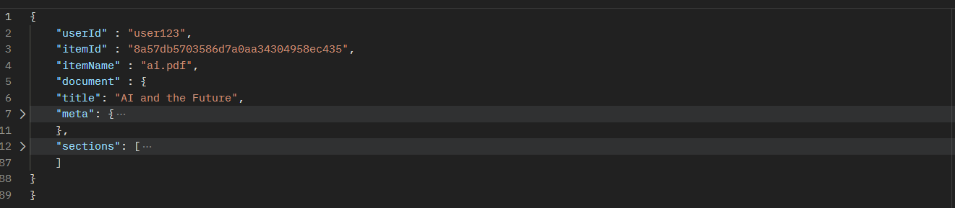

**Note: here ‘document’ field has exactly same structure as return type of 2nd API call.**

**RESPONSE BODY : (SUCCESSFUL UPLOAD)**

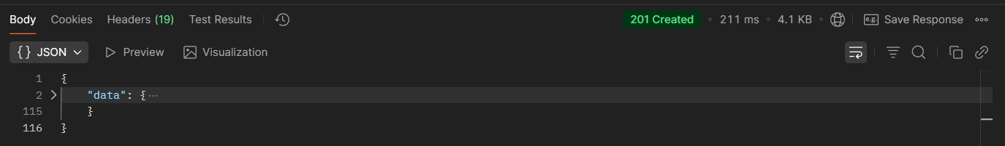

**Note: here ‘data’ = [‘document’ of request body + userId + itemId + itemName + createdAt+ other] just for acknowledgement purpose.**

1. **SAVE MCQS**

**METHOD :**



**ROUTE :**



**REQUEST BODY :**

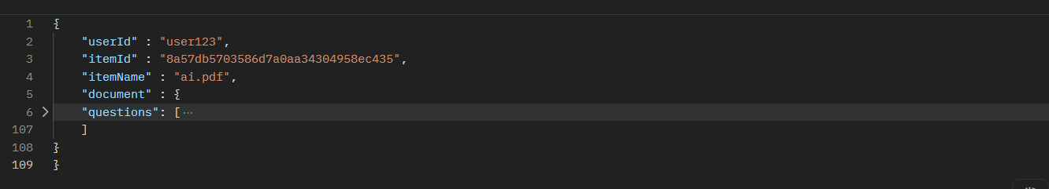

**Note: here ‘document’ field has exactly same structure as return type of 3rd API call.**

**RESPONSE BODY : (SUCCESSFUL UPLOAD)**

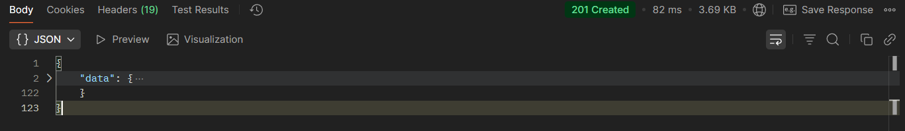

**Note: here ‘data’ = [‘document’ of request body + userId + itemId + itemName + createdAt+ other] just for acknowledgement purpose.**

1. **SAVE FLASHCARDS**

**METHOD :**



**ROUTE :**



**REQUEST BODY :**

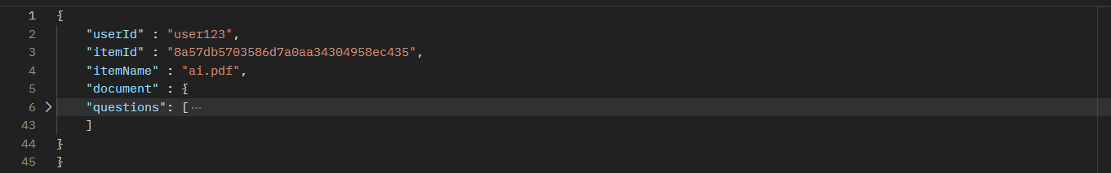

**Note: here ‘document’ field has exactly same structure as return type of 4th API call.**

**RESPONSE BODY : (SUCCESSFUL UPLOAD)**

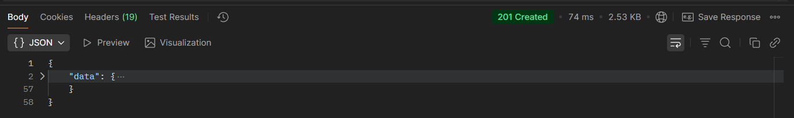

**Note: here ‘data’ = [‘document’ of request body + userId + itemId + itemName + createdAt + other] just for acknowledgement purpose.**

1. **FETCH ALL SAVED NOTES OF A USER**

**METHOD :**



**ROUTE :**



**QUERY PARAMS :**



**RESPONSE BODY : (SUCCESSFUL)**

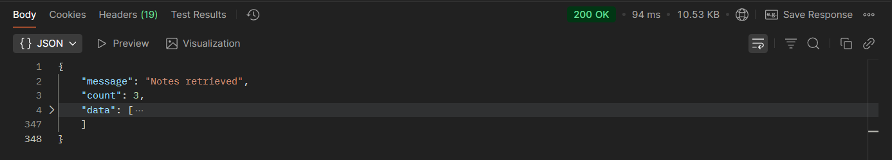

**data is an array of objects of type :**

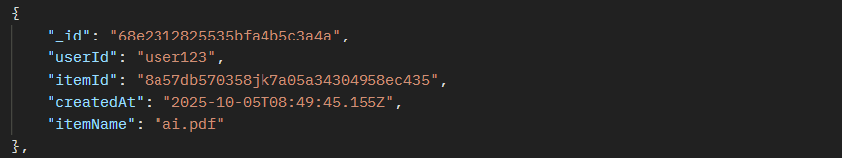

1. **FETCH ALL SAVED MCQS OF A USER**

**METHOD :**



**ROUTE :**



**QUERY PARAMS :**



**RESPONSE BODY : (SUCCESSFUL)**

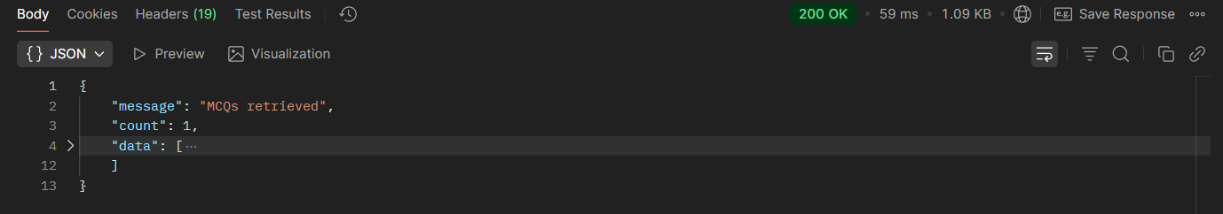

**data is an array of objects of type:**

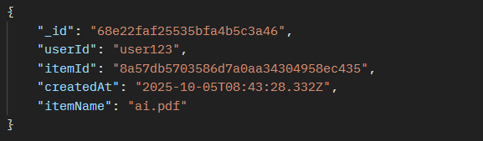

1. **FETCH ALL SAVED FCS OF A USER**

**METHOD :**



**ROUTE :**



**QUERY PARAMS :**



**RESPONSE BODY : (SUCCESSFUL)**

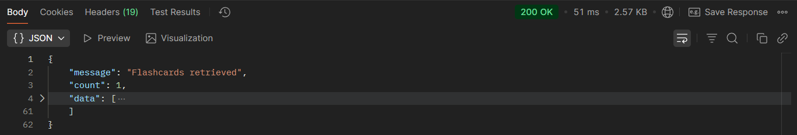

**data is an array of objects of type:**

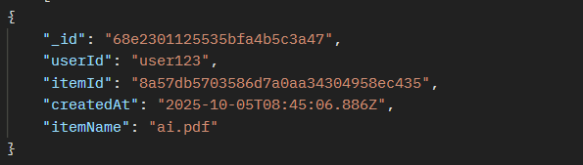

1. **GET A SINGLE SAVED NOTES**

**METHOD :**



**ROUTE :**



**QUERY PARAMS :**

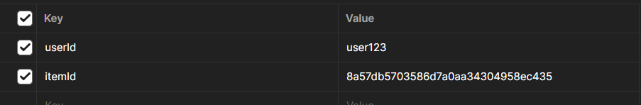

**RESPONSE BODY : (SUCCESSFUL)**

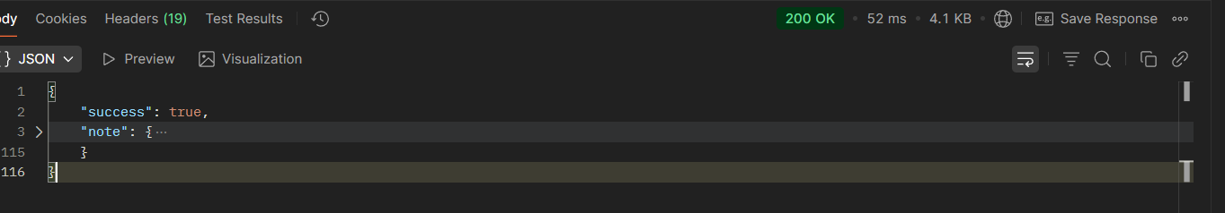

**note is an object of type [object returned by 2nd API call + userId + itemId + itemName + other].**

1. **GET A SINGLE SAVED MCQS**

**METHOD :**



**ROUTE :**



**QUERY PARAMS :**



**RESPONSE BODY : (SUCCESSFUL)**

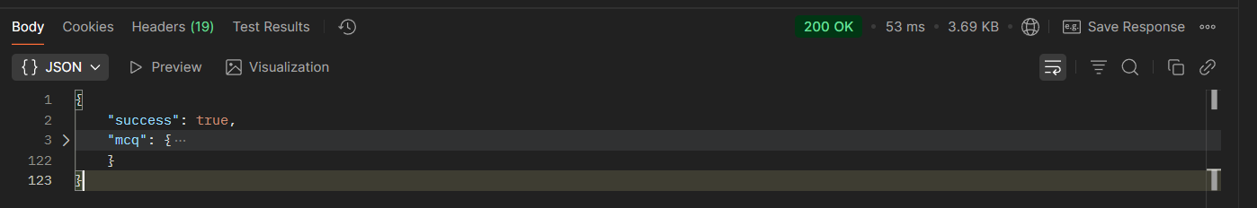

**mcq is an object of type [object returned by 3rd API call + userId + itemId + itemName + other].**

1. **GET A SINGLE SAVED FCS**

**METHOD :**



**ROUTE :**



**QUERY PARAMS :**



**RESPONSE BODY : (SUCCESSFUL)**

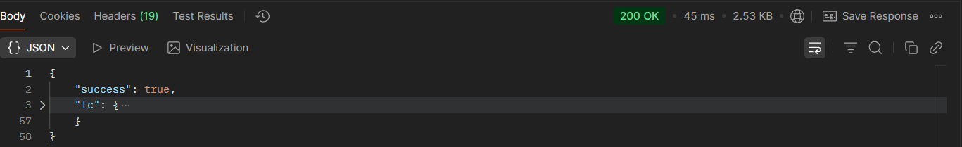

**mcq is an object of type [object returned by 4th API call + userId + itemId + itemName + other].**

1. **DELETE A SINGLE SAVED NOTES**

**METHOD :**



**ROUTE :**



**QUERY PARAMS :**



**RESPONSE BODY : (SUCCESSFUL)**

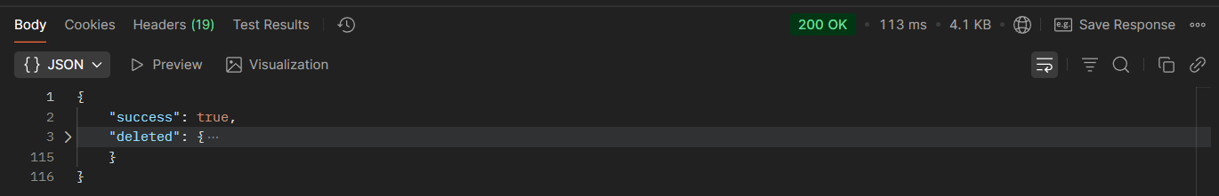

**deleted is an object of type [object returned by 2nd API call + userId + itemId + itemName + other].**

1. **DELETE A SINGLE SAVED MCQS**

**METHOD :**



**ROUTE :**



**QUERY PARAMS :**



**RESPONSE BODY : (SUCCESSFUL)**



**deleted is an object of type [object returned by 3rd API call + userId + itemId + itemName + other].**

1. **DELETE A SINGLE SAVED FCS**

**METHOD :**



**ROUTE :**



**QUERY PARAMS :**



**RESPONSE BODY : (SUCCESSFUL)**



**deleted is an object of type [object returned by 4th API call + userId + itemId + itemName + other].**

1. **FOLLOW UP & GENERATE NOTES**

**METHOD :**



**ROUTE :**



**QUERY PARAMS :**

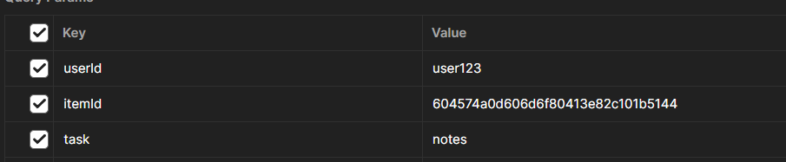

**REQUEST BODY :**

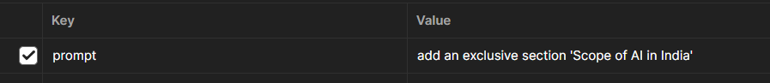

**RESPONSE BODY : (SUCCESSFUL UPLOAD)**

**Same as 2nd API call.**

1. **FOLLOW UP & GENERATE MCQS**

**METHOD :**



**ROUTE :**



**QUERY PARAMS :**



**REQUEST BODY :**



**RESPONSE BODY : (SUCCESSFUL UPLOAD)**

**Same as 3rd API call.**

1. **FOLLOW UP & GENERATE FCS**

**METHOD :**



**ROUTE :**



**QUERY PARAMS :**



**REQUEST BODY :**

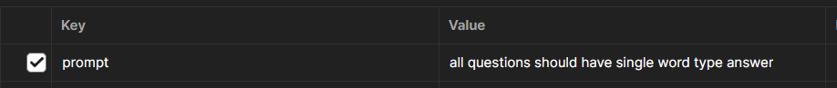

**RESPONSE BODY : (SUCCESSFUL UPLOAD)**

**Same as 4th API call.**